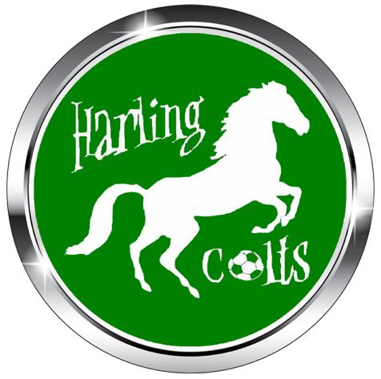

Anti-Discrimination Policy
Our commitment is to eliminate discrimination whether by reason of gender, sexual orientation,
race, nationality, ethnic origin, colour, religion or ability and to encourage equal opportunities.
As the governing body of the game, The Football Association is responsible for setting standards
and values to apply throughout the game at every level.
Football belongs to, and should be enjoyed by everyone equally.
Harling Colts Football Club is responsible for setting standards and values to apply throughout the club
at every level. Football belongs to and should be enjoyed by everyone, equally.
Equality of opportunity at Harling Colts Football Club means that in all our activities we will not
discriminate or in any way treat anyone less favourably, on grounds of sex, sexual orientation,
race, nationality, ethnic origin, colour, religion or disability.
This includes:
• The advertisement for volunteers.
• The selection of candidates for volunteers.
• Courses.
• External coaching and education activities and awards.
• Football development activities.
• Selection for teams.
• Appointments to honorary positions.
Harling Colts Football Club will not tolerate sexual or racially based harassment or other discriminatory
behaviour, whether physical or verbal and will work to ensure that such behaviour is met with
appropriate action in whatever context it occurs.
Harling Colts Football Club is committed to the development programme of ongoing training,
awareness raising events and activities in order to promote the eradication of discrimination
within its own organisation and in the wider context, within football as a whole.

