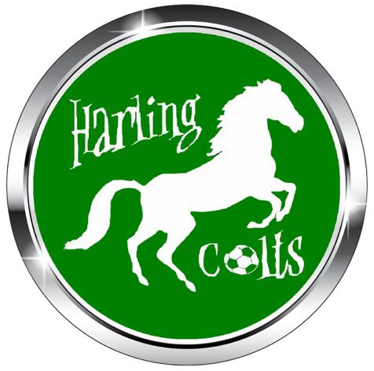

Health & Safety Policy
Harling Colts FC is strongly committed to encouraging our members to take part, but the health,
well-being and safety of each individual is always our paramount concern. We recommend levels
of training dependent on age and ability, and expect our players to participate within these
boundaries.
To support our Health and Safety policy statement we are committed to the following duties:
● Undertake regular, recorded risk assessment of the club premises and all activities
undertaken by the club.
● Create a safe environment by putting health and safety measures in place as identified by
the assessment.
● Ensure that all members are given the appropriate level of training and competition by
regularly assessing individual ability dependant on age, maturity and development.
● Ensure that all members are aware of, understand and follow the club’s health and safety
policy.
● Appoint a competent club member to assist with health and safety responsibilities.
● Ensure that normal operating procedures and emergency operating procedures are in
place and known by all members.
● Provide access to adequate first aid facilities, telephone and qualified first aider at all
times.
● Report any injuries or accidents sustained during any club activity or whilst on the club
premises.
● Ensure that the implementation of the policy is reviewed regularly and monitored for
effectiveness.

As a club member you have a duty to:
● Take reasonable care for your own health and safety and that of others who may be
affected by what you do or not do.
● Cooperate with the club on health and safety issues.
● Correctly use all equipment provided by the club.
● Not interfere with or misuse anything provided for your health, safety or welfare.

