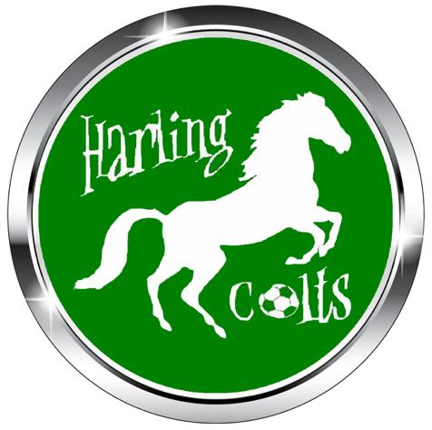

Equality Policy
The aim of this policy is to ensure that everyone is treated fairly and with respect and that our
club is equally accessible to all.
Harling Colts FC is responsible for setting standards and values to apply throughout the club at
every level. Football belongs to and should be enjoyed by anyone who wants to participate in
it.
Harling Colts FC in all its activities will not discriminate or in any way, treat anyone less favourably
on grounds of age, gender, gender reassignment, sexual orientation, marital status, race,
nationality, ethnic origin, colour, religion or belief, ability or disability. The club will ensure it
treats people fairly and with respect and that it will provide access and opportunities for all
members of the community to take part in and enjoy its activities.
Harling Colts FC will not tolerate harassment, bullying, abuse or victimisation of an individual,
which for the purposes of this policy and the actions and sanction applicable is regarded as
discrimination. This includes sexual or racially based harassment or other discrimatory
behaviour, whether physical or verbal. The club will work to ensure that such behaviour is met
with appropriate action in whatever context it occurs.
Harling Colts FC is committed to taking positive action where inequalities exist and to the
development of a programme of ongoing training and awareness raising events and activities
in order to promote the eradication of discrimination and promote equality in football.
Harling Colts FC is committed to a policy of equal treatment of all members and requires all
members to abide and adhere to these policies and the requirements of the Equality Act 2010.
Harling Colts FC commits itself to the immediate investigation of any claims when brought to its
attention, of discrimination on the above grounds and where such is found to be the case, a
requirement that the practice stop and sanctions are imposes as appropriate.
Our commitment is to confront and eliminate discrimination whether by reason of age,
gender, gender reassignment, sexual orientation, marital status, race, nationality, ethnic origin,
colour, religion or belief, ability or disability and to encourage equal opportunities.
This policy is fully supported by the Club Officers who are responsible for the implementation
of this policy.

